## **Objectives**

* Explain React events
* Explain about event handlers
* Define Synthetic event
* Identify React event naming convention

In this hands-on lab, you will learn how to:

* Implement Event handling concept in React applications
* Use this keyword
* Use synthetic event

## **Prerequisites**

The following is required to complete this hands-on lab:

* Node.js
* NPM
* Visual Studio Code

## **Notes**

Estimated time to complete this lab: **90 minutes.**

Create a React Application “eventexamplesapp” to handle various events of the form elements in HTML.

1. Create “Increment” button to increase the value of the counter and “Decrement” button to decrease the value of the counter. The “Increase” button should invoke multiple methods.
   1. To increment the value
   2. Say Hello followed by a static message.

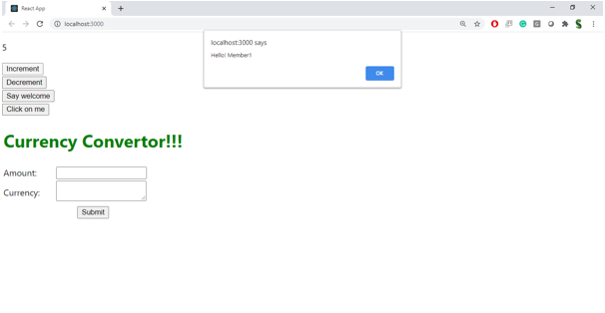

1. Create a button “Say Welcome” which invokes the function which takes “welcome” as an argument.

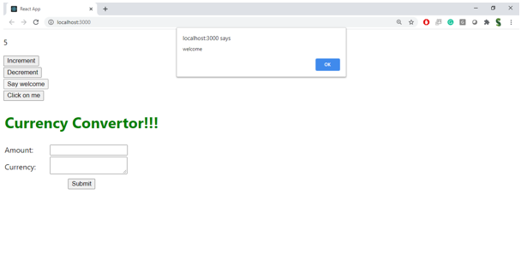

1. Create a button which invokes synthetic event “OnPress” which display “I was clicked”

Create a “CurrencyConvertor” component which will convert the Indian Rupees to Euro when the Convert button is clicked.

Handle the Click event of the button to invoke the handleSubmit event and handle the conversion of the euro to rupees.

**Source Code:**

**CurrencyConvertor.js:**

import React, { useState } from 'react';

function CurrencyConvertor() {

const [amount, setAmount] = useState('');

const [currency, setCurrency] = useState('INR');

const [result, setResult] = useState(null);

const conversionRates = {

INR: 0.011, // INR to Euro

USD: 0.92 // USD to Euro

};

const handleSubmit = (e) => {

e.preventDefault();

const value = parseFloat(amount);

if (!isNaN(value)) {

const rate = conversionRates[currency] || 0;

const euroValue = value * rate;

setResult(`${value} ${currency} is approximately ${euroValue.toFixed(2)} Euros`);

} else {

setResult("Invalid amount");

}

};

return (

<form onSubmit={handleSubmit} style={{ display: 'flex', flexDirection: 'column', maxWidth: '300px' }}>

<label style={{ marginBottom: '10px' }}>

Amount:

<input

type="number"

placeholder="e.g. 100"

value={amount}

onChange={(e) => setAmount(e.target.value)}

style={{ padding: '8px', width: '100%', marginTop: '5px' }}

/>

</label>

<label style={{ marginBottom: '10px' }}>

Currency:

<select

value={currency}

onChange={(e) => setCurrency(e.target.value)}

style={{ padding: '8px', width: '100%', marginTop: '5px' }}

>

<option value="INR">INR</option>

<option value="USD">USD</option>

</select>

</label>

<button

type="submit"

style={{

margin: '10px auto',

padding: '8px 16px',

backgroundColor: '#4CAF50',

color: 'white',

border: 'none',

cursor: 'pointer'

}}

>

Convert

</button>

{result && (

<div style={{ marginTop: '15px', textAlign: 'center', lineHeight: '1.6' }}>

{result.split(' ').map((word, i) => <div key={i}>{word}</div>)}

</div>

)}

</form>

);

}

export default CurrencyConvertor;

**App.js**

import React, { useState } from 'react';

import CurrencyConvertor from './CurrencyConvertor';

function App() {

const [count, setCount] = useState(0);

const increment = () => {

setCount(count + 1);

sayHello();

};

const decrement = () => {

setCount(count - 1);

};

const sayHello = () => {

console.log("Hello! This is a static message.");

};

const sayWelcome = (message) => {

alert(message);

};

const handleClick = () => {

alert("Hello member!!");

};

return (

<div style={{ padding: '20px', fontFamily: 'Arial' }}>

<h2>Counter: {count}</h2>

<div style={{ display: 'flex', flexDirection: 'column', gap: '10px', width: '200px' }}>

<button onClick={increment}>Increment</button>

<button onClick={decrement}>Decrement</button>

<button onClick={() => sayWelcome("Welcome!")}>Say Welcome</button>

<button onClick={handleClick}>Click on Me</button>

</div>

<h2 style={{ color: 'green', fontSize: '30px', marginTop: '30px' }}>Currency Converter</h2>

<CurrencyConvertor />

</div>

);

}

export default App;

**Output:** 